# AWS Cost Management Instructions

Follow this procedure to create an AWS usage budget that will alert you via email if your consumption of compute and storage services (including EMR) exceeds some monthly maximum cost that you can set. This is one way to protect yourself from being surprised by a high monthly bill if you forget to terminate use of some AWS resources.

**To create a usage budget with alerts on high use**

1. Sign in to the AWS Management Console and enter “AWS Cost Explorer” into the search box at the top of the page and then select **AWS Cost Explorer** from the Services list



1. In the **AWS Cost Management** navigation pane, choose **Budgets**



1. At the top right of the next page, choose **Create budget**.



1. At the next page, for **Choose budget type** (see below)
   1. Accept the default) **Use a template (simplified)**
   2. Then, select Monthly cost budget.

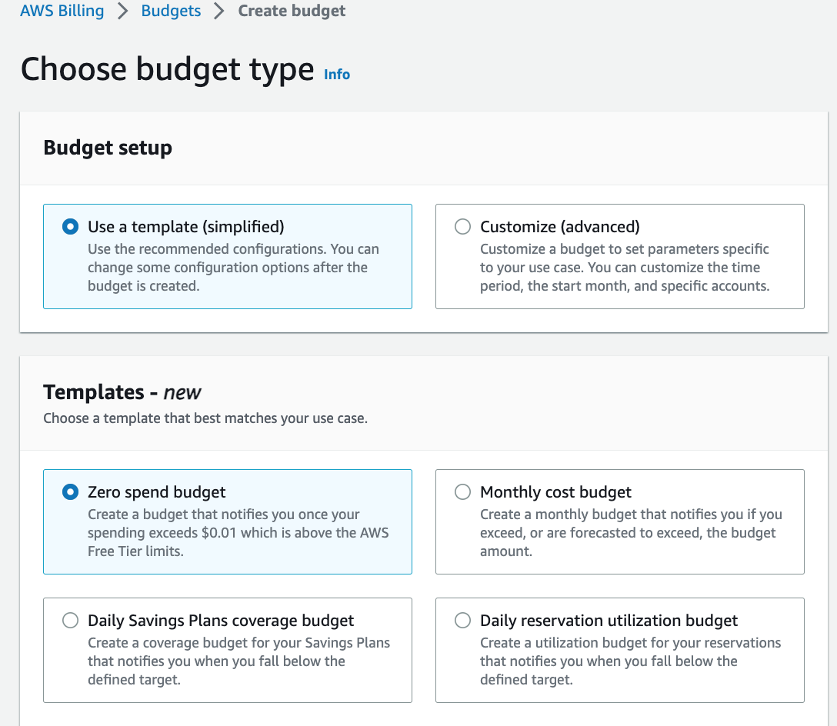

1. Now scroll down to the Monthly cost budget – Template section

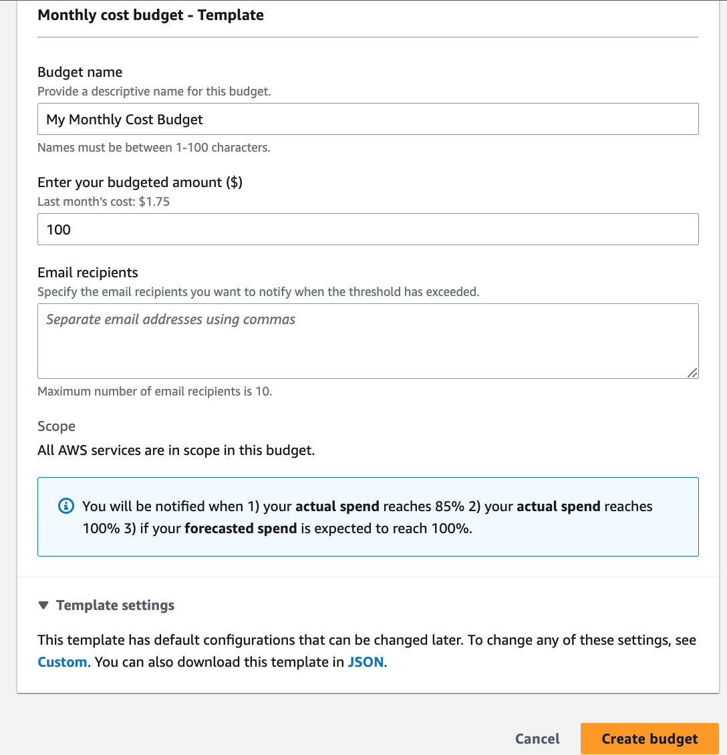

* 1. Under **Enter your budget amount** enter the total amount you expect to spend each month, use something like **$25.**
  2. Specify your email address into the “Email recipients” box
  3. Select “Create budget”

Now you should see something like this, and you are done!

